Sacred Sounds Concert
Bronze & Branch
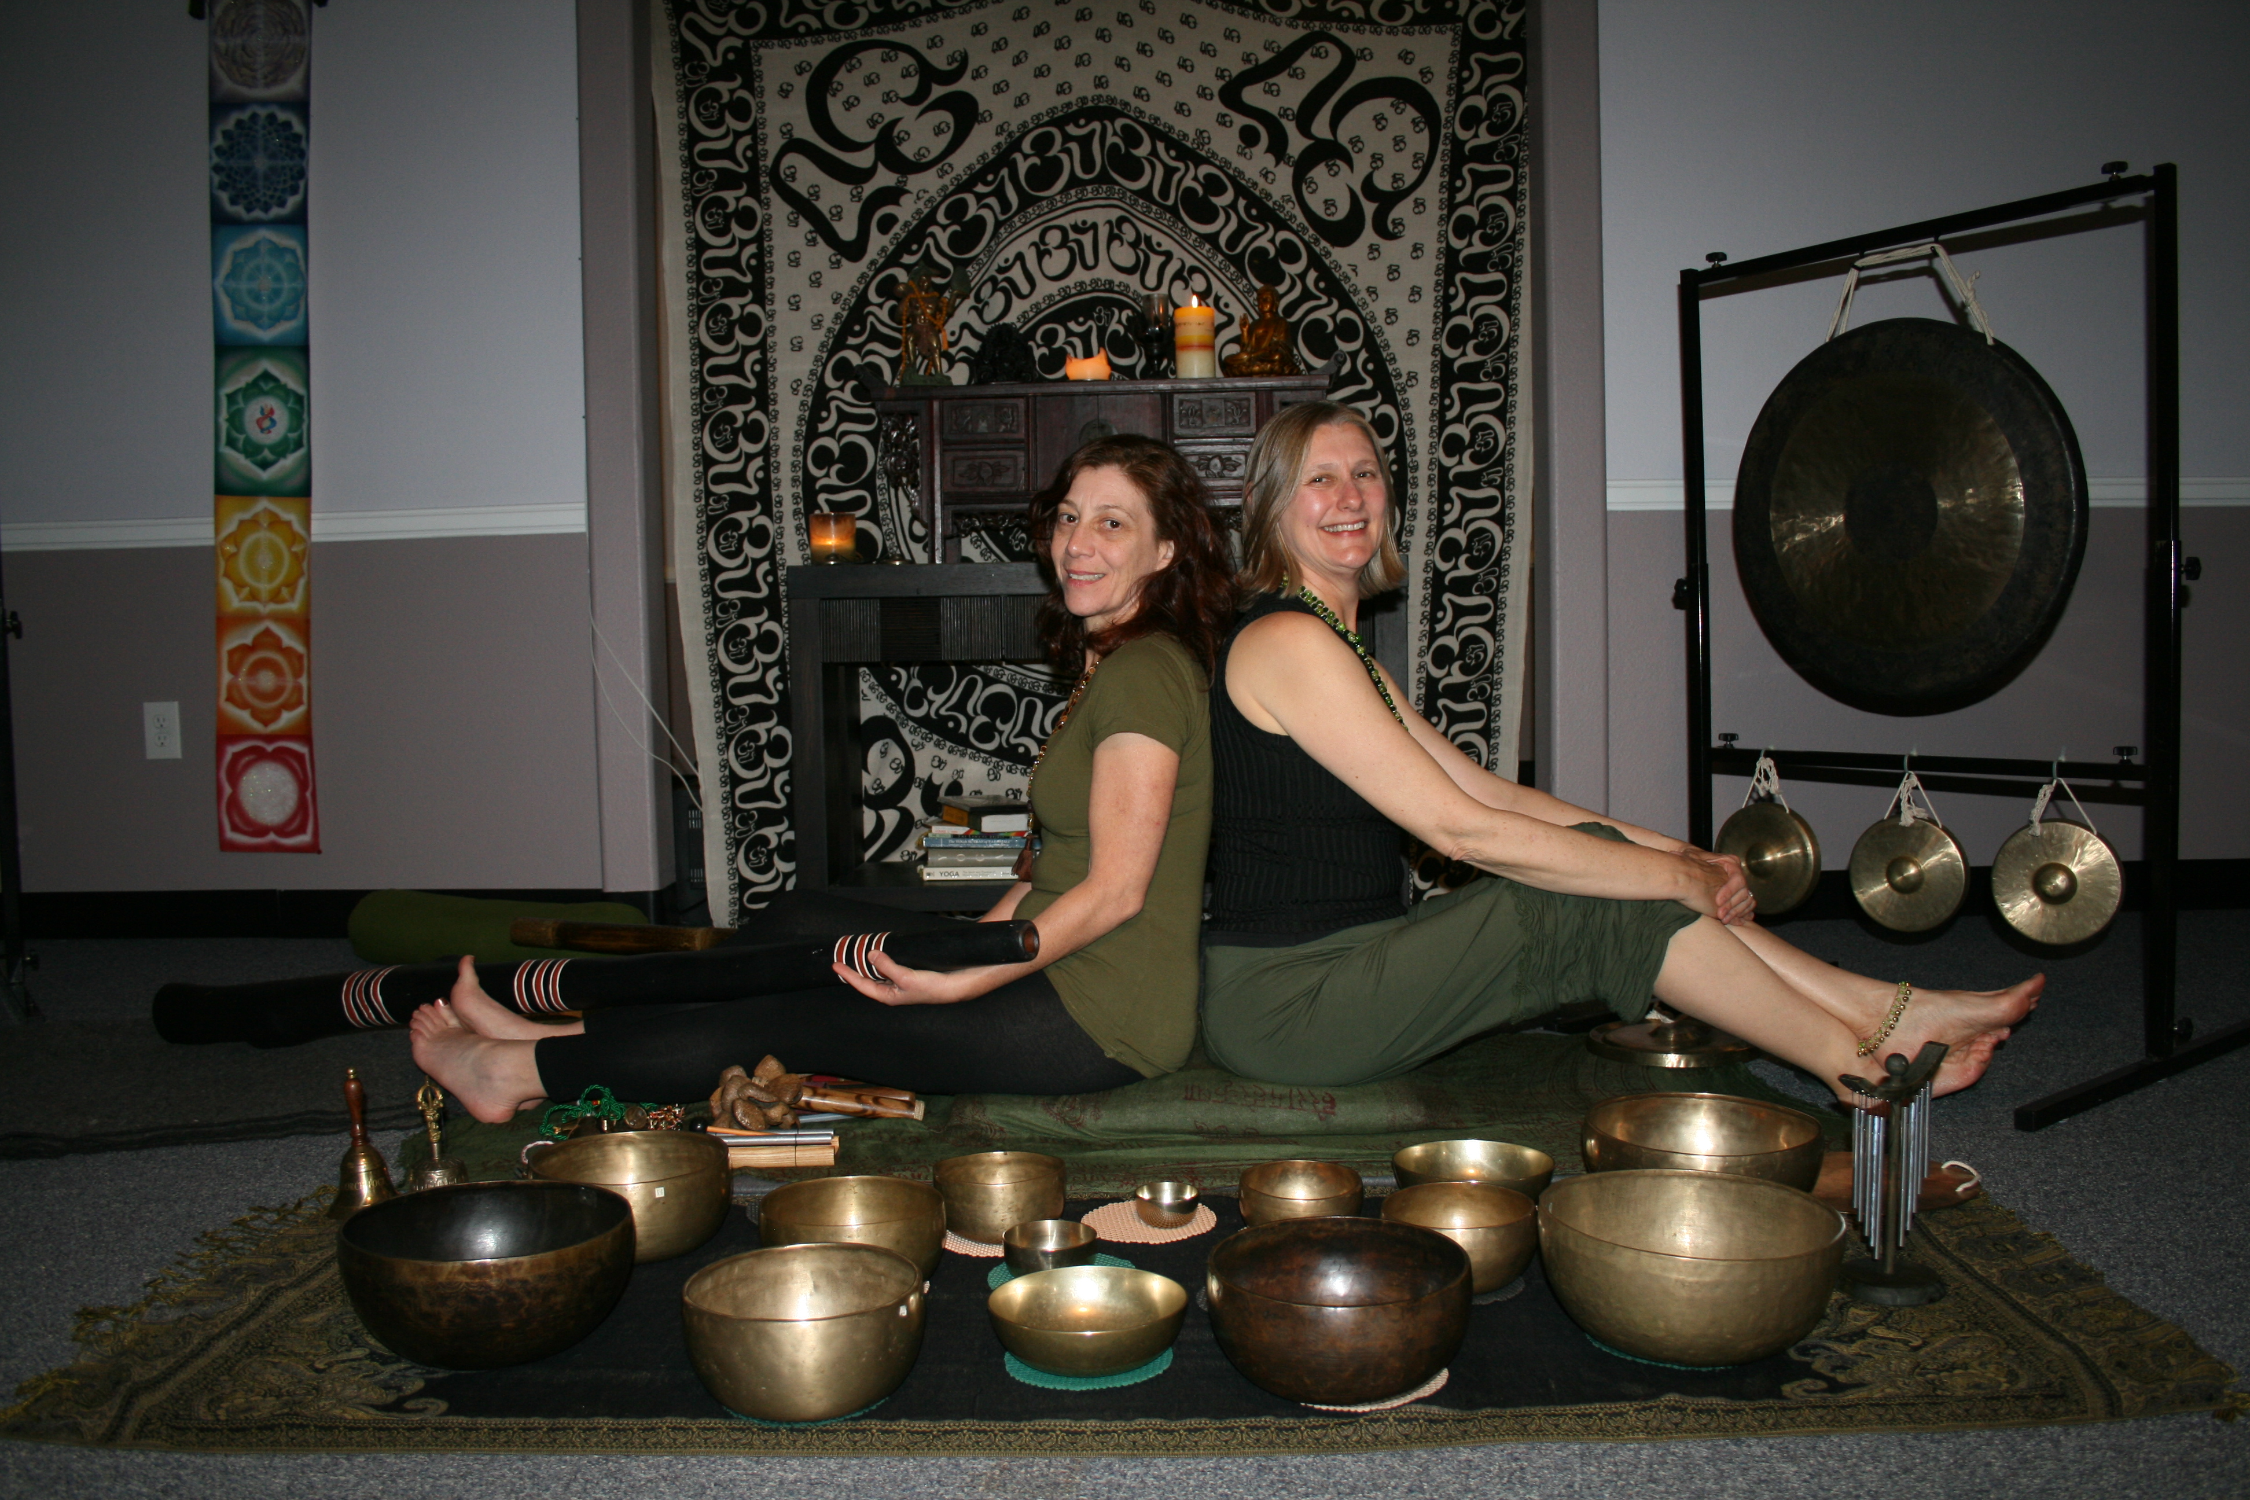
Janice Motley & Barbara Seymour

A Sound Healing Experience
Enter the world of deep healing and relaxation with the sound therapy of Himalayan singing bowls, gongs and the didgeridoo. The inner space, produced by the sacred tones, quickly moves you out of your mind into a meditative state. These ancient musical instruments easily transport you to a place of peaceful awareness where you can become one with the vibrations. The singing bowls starts the journey that brings you into a place of peace and calmness. The didgeridoo takes you deeper with its resonating, aboriginal sounds.
Friday, April 26, 2013 - 7:00 pm – 8:00 pm

Debra Hodgen Wellness
Location: MBS Precision Pilates and Wellness
7220 Avenida Encinas # 207, Carlsbad 92011

Reservation: Debra Hodgen 760/420-2104 Cost: $ 15

A word of caution: Listening to the harmonic voices of each
instrument may lead you to abandoned bliss.

